**DoccPlus Medical System**

Software Requirements Specification

Version <1.0>

Group Details

|  |  |
| --- | --- |
| **Name** | **Roll-Number** |
| Abdul Saboor | 20L-1113 |
| Fatima Azfar | 20L-1027 |
| Komal Akhlaq | 20L-1278 |
| Mohammad Anas | 20L-1289 |
| Saad Ahmed | 20L-1264 |

Revision History

|  |  |  |  |
| --- | --- | --- | --- |
| **Date** | **Version** | **Description** | **Author** |
| <04/29/22> | <1.0> | SRS 1.0 | Group-1 |

Table of Contents

1.Introduction 5

1.1 Purpose 5

1.2 Scope 5

1.3 Definitions, Acronyms, and Abbreviations 5

1.4 References 6

1.5 Overview 6

2.Overall Description 6

3.Specific Requirements 7

3.1 Functionality 7

**3.1.1** **Provide comprehensive doctor details.** 7

**3.1.2** **Provide search facility.** 7

**3.1.3** **Maintain user profile.** 7

**3.1.4** **Provide a personalized profile.** 7

**3.1.5** **Provide customer support.** 8

**3.1.6** **Email confirmation.** 8

**3.1.7** **Detailed invoice for the customer.** 8

**3.1.8** **Provide multiple subscription methods.** 8

**3.1.9** **Provide online tax calculations.** 8

**3.1.10** **Allow multiple payment methods.** 8

**3.1.11** **Allow online change or cancellation of treatment.** 9

**3.1.12** **Allow online doctor reviews and ratings.** 9

**3.1.13** **Online initiation of treatment.** 9

3.2 Usability 9

**3.2.1** **Graphical User Interface** 9

3.3 Reliability & Availability 9

**3.3.1** **Back-end Internal Computers** 9

**3.3.2** **Internet Service Provider** 9

3.4 Performance 10

3.5 Security 10

**3.5.1** **Data Transfer** 10

**3.5.2** **Data Storage** 10

3.6 Supportability 10

**3.6.1** **Configuration Management Tool** 10

3.7 Design Constraints 10

**3.7.1** **Standard Development Tools** 10

**3.7.2** **Web-Based Product** 11

3.8 Interfaces 11

**3.8.1** **User Interfaces** 11

**3.8.2** **Hardware Interfaces** 11

**3.8.3** **Software Interfaces** 11

**3.8.4** **Communications Interfaces** 12

3.9 Legal, Copyright, and Other Notices 12

3.10 Applicable Standards 12

4.Supporting Information 12

# Introduction

The introduction of the Software Requirements Specification (SRS) provides an overview of the entire SRS with purpose, scope, definitions, acronyms, abbreviations, references and overview of the SRS. The aim of this document is to gather and analyze and give an in-depth insight of the complete **DoccPlus Medical System** by defining the problem statement in detail. Nevertheless, it also concentrates on the capabilities required by stakeholders and their needs while defining high-level product features. The detailed requirements of the **DoccPlus Medical System** are provided in this document.

## Purpose

The purpose of the document is to collect and analyze all assorted ideas that have come up to define the system, its requirements with respect to consumers. Also, we shall predict and sort out how we hope this product will be used in order to gain a better understanding of the project, outline concepts that may be developed later, and document ideas that are being considered but may be discarded as the product develops.

In short, the purpose of this SRS document is to provide a detailed overview of our software product, its parameters and goals. This document describes the project's target audience and its user interface, and hardware and software requirements. It defines how our client, team and audience see the product and its functionality. Nonetheless, it helps any designer and developer to assist in software delivery lifecycle (SDLC) processes.

## Scope

Primarily, the scope pertains to the DoccPlus product features for making DoccPlus Medical System live. It focuses on the company, the stakeholders and applications, which allow for online sales, distribution and marketing of electronics.

This SRS is also aimed at specifying the requirements of the software to be developed but it can also be applied to assist in the selection of in-house and commercial software products. The standard can be used to create software requirements specifications directly or can be used as a model for defining an organization or project-specific standard. It does not identify any specific method, nomenclature or tool for preparing an SRS.

## Definitions, Acronyms, and Abbreviations

|  |  |
| --- | --- |
| Configuration | It means a product which is available / Selected from a catalogue can be customized. |
| FAQ | Frequently Asked Questions |
| CRM | Customer Relationship Management |
| RAID 5 | Redundant Array of Inexpensive Disk/Drives |

## References

The references are:

* DoccPlus Structural Model
* DoccPlus Behavioral Model
* DoccPlus NFR Model
* Vision Draft 5
* https://www.google.com/url?sa=t&rct=j&q=&esrc=s&source=web&cd=&ved=2ahUKEwjcgszG-rb3AhVW8LsIHcHZAKYQFnoECAYQAQ&url=https%3A%2F%2Fwww.utdallas.edu%2F~chung%2FRE%2FPresentations07S%2FTeam_1_Doc%2FDocuments%2FSRS4.0.doc&usg=AOvVaw2zaGGnBB9yNttcKsuBifee

## Overview

The remaining sections of this document provide a general description, including the characteristics of the users of this project, the product's hardware, and the functional and data requirements of the product.  A general description of the project is discussed in section 2 of this document.  Section 3 gives the functional requirements, data requirements and constraints and assumptions made while designing the application.  It also gives the user viewpoint of the product.  Section 3 also gives the specific requirements of the product.  Section 3 also discusses the external interface requirements and gives a detailed description of functional requirements. Section 4 is for supporting information.

# Overall Description

This document contains the problem statement that the current system is facing which is hampering the growth opportunities of the company. It further contains a list of the stakeholders and users of the proposed solution. It also illustrates the needs and wants of the stakeholders that were identified in the brainstorming exercise as part of the requirements workshop. It further lists and briefly describes the major features and a brief description of each of the proposed systems.

The following SRS contains the detailed product perspective from different stakeholders. It provides the detailed product functions of DoccPlus with user characteristics permitted constraints, assumptions and dependencies and requirements subsets.

# Specific Requirements

The specific requirements are –

## Functionality

Introduction –

This subsection contains the requirements for the DoccPlus. These requirements are organized by the features discussed in the proposal document. Features from proposal documents are then refined into use case diagrams and sequence diagrams to best capture the functional requirements of the system. All these functional requirements can be traced using the traceability matrix.

### **Provide comprehensive doctor details.**

1. The system shall display detailed information about the selected doctor.
2. The system shall provide browsing options to see doctor details.

### **Provide search facility.**

1. The system shall enable the user to enter the search text on the screen.
2. The system shall enable the user to select options on the screen to search.
3. The system shall display all the matching doctors based on the search
4. The system shall display only 5 matching results on the current screen.
5. The system shall enable the user to navigate between the search results.
6. The system shall notify the user when no matching product is found on the search.

### **Maintain user profile.**

1. The system shall allow the user to create a profile and set his credential.
2. The system shall authenticate user credentials to view the profile.
3. The system shall allow the user to update the profile information.

### **Provide a personalized profile.**

1. The system shall display both the active and completed treatment history in the patient profile.
2. The system shall allow the user to select the treatment from the order history.
3. The system shall display detailed information about the selected treatment.

### **Provide customer support.**

1. The system shall provide online help, FAQ customer support, and sitemap options for customer support.
2. The system shall allow the user to select the support type he wants.
3. The system shall allow the user to enter the doctor and treatment information for support.
4. The system shall display the customer support contact numbers on the screen.
5. The system shall allow the user to enter the contact number for support personnel to call.
6. The system shall display the online help upon request.
7. The system shall display the FAQs upon request.

### **Email confirmation.**

1. The system shall maintain customer email information as a required part of the customer profile.
2. The system shall send an account confirmation to the user through email.

### **Detailed invoice for the customer.**

1. The system shall display a detailed invoice for the current order once treatment is confirmed.
2. The system shall optionally allow the user to print the invoice.

### **Provide multiple subscription methods.**

1. The system shall display different subscription models provided by the application.
2. The system shall enable the user to select the subscription models based on interests.
3. The system shall display the subscription charges.

### **Provide online tax calculations.**

1. The system shall calculate tax for the transaction.
2. The system shall display tax information for the transaction.

### **Allow multiple payment methods.**

1. The system shall display available payment methods for payment.
2. The system shall allow the user to select the payment method for the transaction.

### **Allow online change or cancellation of treatment.**

1. The system shall display the treatments that are eligible to change.
2. The system shall allow the user to select the treatment to be changed.
3. The system shall allow the user to cancel the treatment.
4. The system shall allow the user to change the payment method.
5. The system shall notify the user about any changes made to the treatment.

### **Allow online doctor reviews and ratings.**

1. The system shall display the reviews and ratings of each Doctor when it is selected.
2. The system shall enable the user to enter their reviews and ratings.

### **Online initiation of treatment.**

1. The system shall allow the user to confirm the treatment.
2. The system shall enable the user to enter the payment information for treatment.

## Usability

### **Graphical User Interface**

1. The system shall provide a uniform look and feel between all the web pages.
2. The system shall provide a digital image for each doctor in the doctor catalogue.
3. The system shall provide the use of icons and toolbars.

## Reliability & Availability

### **Back-end Internal Computers**

1. The system shall provide storage of all databases on redundant computers with automatic switchover.
2. The system shall provide for the replication of databases to off-site storage locations.
3. The system shall provide RAID V Disk Stripping on all database storage disks.

### **Internet Service Provider**

1. The system shall provide a contractual agreement with an internet service provider for T3 access with 99.9999% availability.
2. The system shall provide a contractual agreement with an internet service provider who can provide 99.999% availability through their network facilities onto the internet.

## Performance

1. The product shall be based on the web and has to be run from a web server.
2. The product shall take initial load time depending on internet connection strength which also depends on the media from which the product is run.
3. The performance shall depend upon the hardware components of the client/customer.

## Security

### **Data Transfer**

1. The system shall use secure sockets in all transactions that include any confidential customer information.
2. The system shall automatically log out all customers after a period of inactivity.
3. The system shall confirm all transactions with the customer’s web browser.
4. The system shall not leave any cookies on the customer’s computer containing the user’s password.
5. The system shall not leave any cookies on the customer’s computer containing any of the user’s confidential information.

### **Data Storage**

1. The customer’s web browser shall never display a customer’s password. It shall always be echoed with special characters representing typed characters.
2. The customer’s web browser shall never display a customer’s credit card number after retrieving it from the database. It shall always be shown with just the last 4 digits of the credit card number.
3. The system’s back-end servers shall never display a customer’s password. The customer’s password may be reset but never shown.
4. The system’s back-end servers shall only be accessible to authenticated administrators.

## Supportability

### **Configuration Management Tool**

1. The source code developed for this system shall be maintained in the configuration management tool.

## Design Constraints

### **Standard Development Tools**

1. The system shall be built using bubble.io, a web page development tool that conforms to both IBM’s CUA standards and Microsoft’s GUI standards.

### **Web-Based Product**

1. There are no memory requirements
2. The computers must be equipped with web browsers such as Internet explorer.
3. The product must be stored in such a way that allows the client easy access to it.
4. Response time for loading the product should take no longer than five minutes.
5. General knowledge of basic computer skills is required to use the product

## Interfaces

1. There are many types of interfaces as such supported by the DoccPlus software system namely; User Interface, Software Interface and Hardware Interface.
2. The protocol used shall be HTTP.
3. The Port number used will be 80.
4. There shall be a logical address of the system in IPv4 format.

### **User Interfaces**

1. The user interface for the software shall be compatible with any browser such as Google Chrome, Firefox or Apple Safari by which the user can access the system.
2. The user interface shall be implemented using any tool or software package like Java Applet, MS FrontPage, EJB etc.

### **Hardware Interfaces**

1. Since the application must run over the internet, all the hardware shall require to connect internet will be the hardware interface for the system. E.g., Modem, WAN – LAN, Ethernet Cross-Cable.

### **Software Interfaces**

1. The system shall communicate with the browser to identify all the available components to configure the product.
2. The system shall communicate with the content manager to get the product specifications, offerings and promotions.
3. The system shall communicate with the payment provider system to identify available payment methods, validate the payments and process payment.
4. The system shall communicate to the credit management system for handling financing options.
5. The system shall communicate with the CRM system to provide support.
6. The system shall communicate with the Sales system for order management.
7. The system shall communicate with the external Tax system to calculate tax.
8. The system shall be VeriSign like software which shall allow the users to complete the secured transaction. This usually shall be the third-party software system which is widely used for internet transactions.

### **Communications Interfaces**

1. The system shall use the HTTP protocol for communication over the internet and the intranet communication will be through TCP/IP protocol suite.

## Legal, Copyright, and Other Notices

1. DoccPlus should display the disclaimers, copyright, wordmark, trademark and product warranties of DoccPlus Inc.

## Applicable Standards

1. It shall be as per the industry standards.

# Supporting Information

Please refer to the following document:

1. 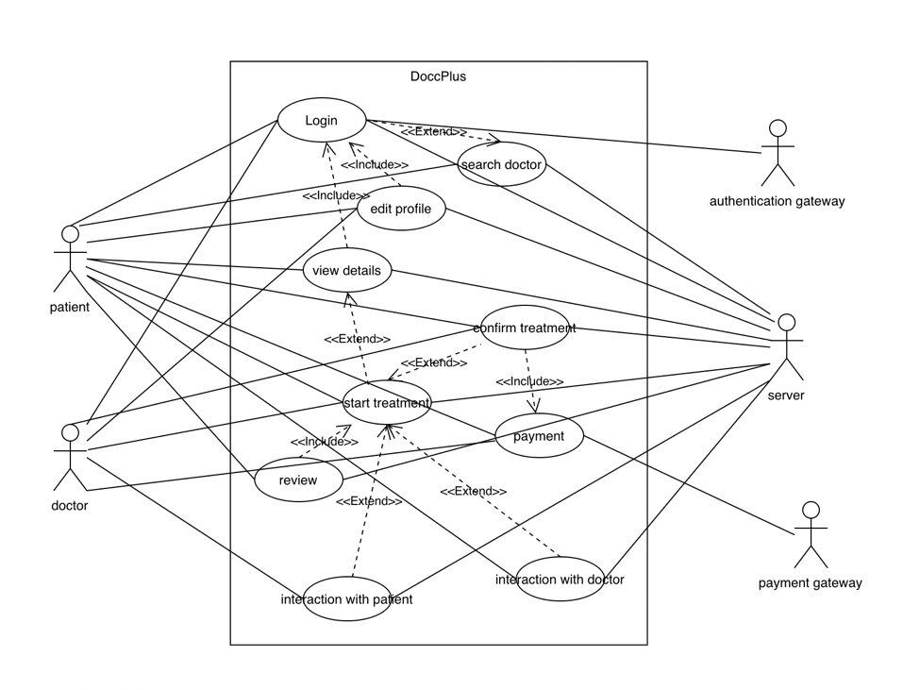Proposal document for DoccPlus.
2. Use case analysis.